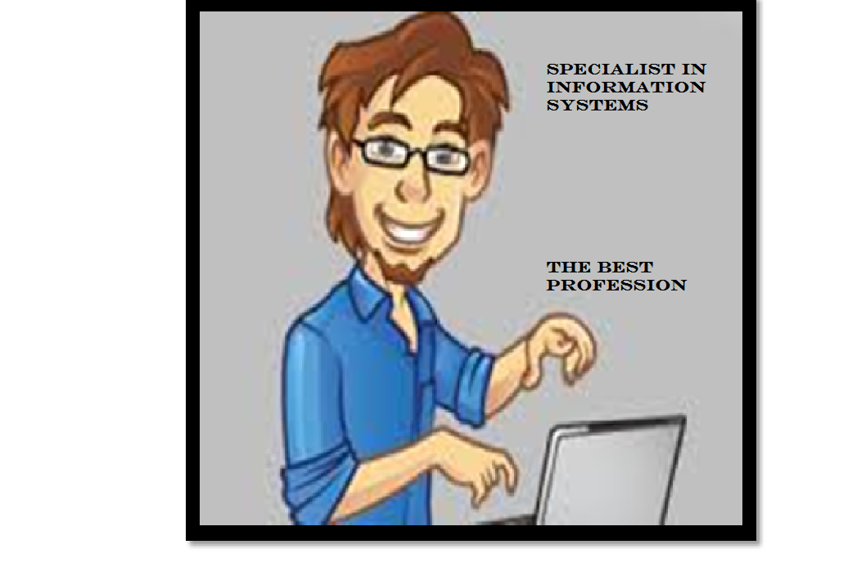
«My future profession».
My specialist profession on the information systems, serving creation and the operation (IS), automating problems of organizational management of business firms and the budgetary establishments. Many people don't understand this profession is how important.
Today it is conventional that (IS) completely computerized.
The profession the specialist in information systems includes various databases.
We will begin with that any large enterprise is required in information systems its value in facilitating work of workers.
The first that it is necessary to tell, it that information systems considerably releases workers from work routine due to its automation.
One more positive moment is that information systems considerably provides more rational information processings on the computer. Thereby we can come to conclusion that the company which uses information systems that is the successful company.
In summary I can tell that though some people say that the profession of the programmer damages health as a lot of time you work at the computer that harms to sight. Summing up the result, it is possible to tell that the profession of the programmer is very developed as presently all keeps on information technologies. The profession of the programmer will be always and everywhere is demanded.

