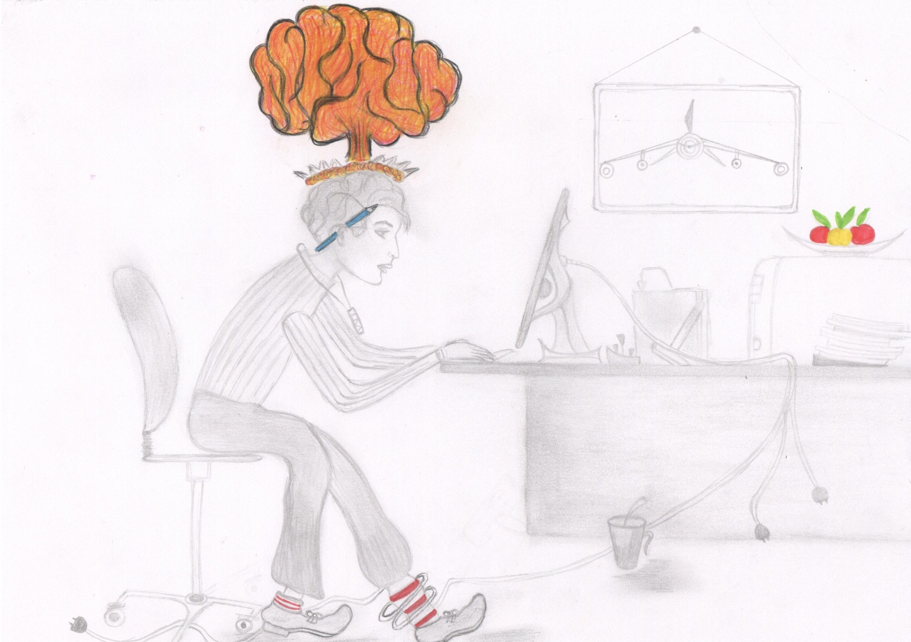

To begin with, we study in a college. Our future trade is computer system and complexes. It is generally agreed today that we can’t imagine our everyday life without computers, automatized systems and various nets. Just look around! Everything we come in contact with is directly or indirectly connected with computer systems.
I mean banks, hospitals, supermarkets, libraries, devices, transport etc. And what is more all our life is a huge system. It is a well-known fact that different countries spend great sums of money developing IT-technologies. For example, in Tatarstan the construction of IT-city Innopolice has begun in 2012. So it’s quite evident that future begins today! In conclusion I’d like to point our that our trade is very actual and will remain actual for many, many years!

